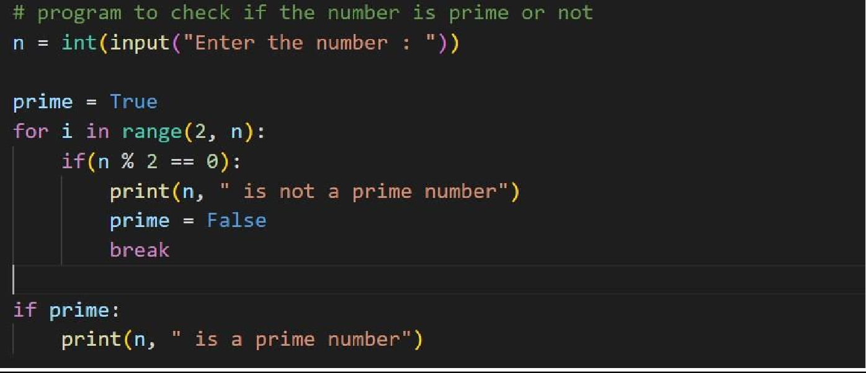Program1:

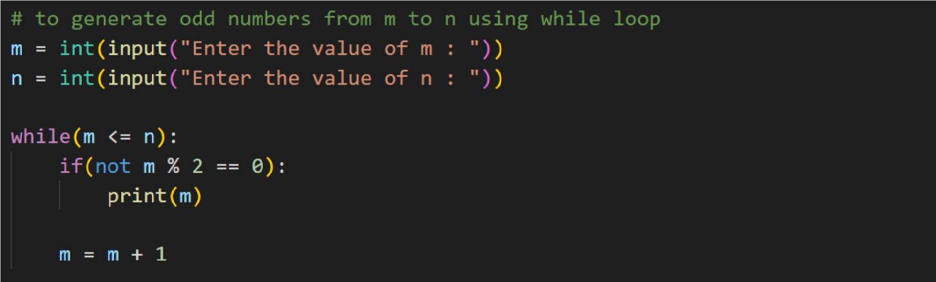Program2:

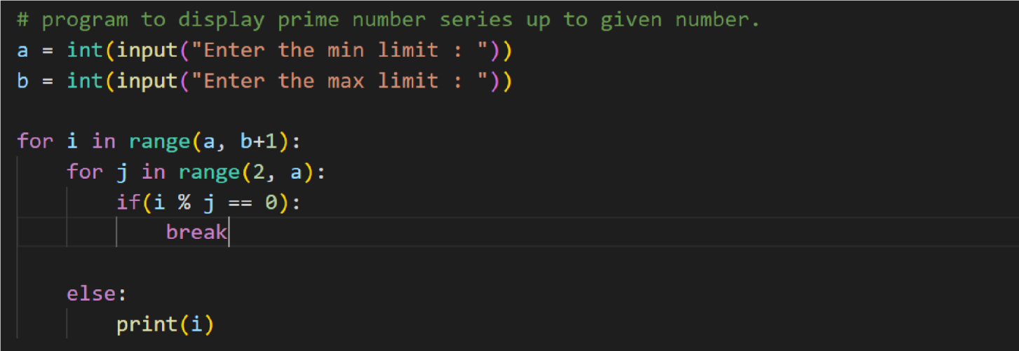Program3:

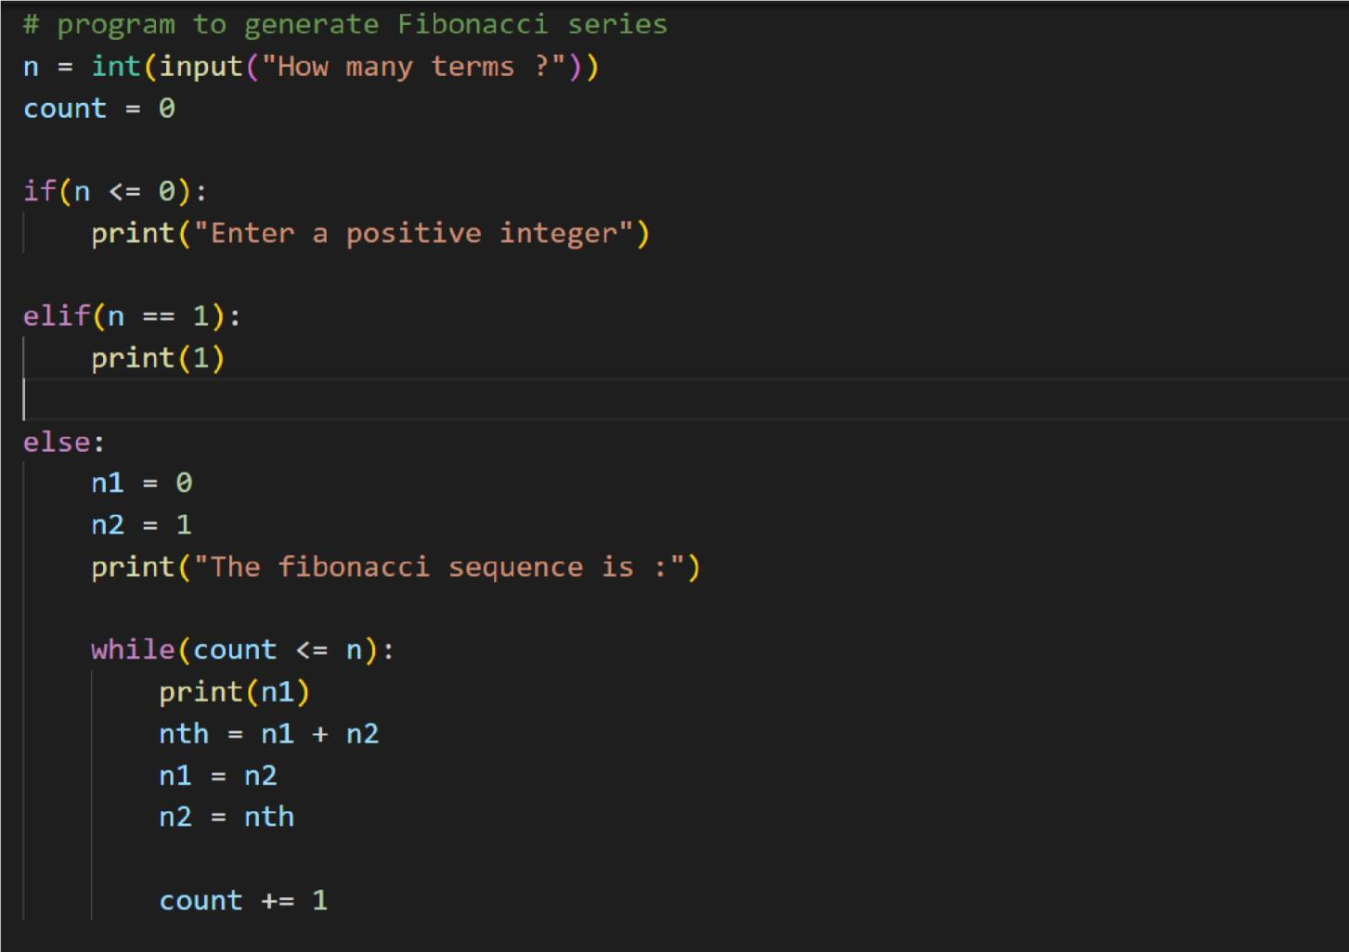Program4:

Submitted by,(TheTeamof)

Namit A R

Nivethitha M

Saranya R

Venkadesh S R